Smart Room Environment Monitoring Application Using Flutter and Arduino-Based Sensors
ITEC90 – System Integration II

1. Project Description
- Purpose: This project was developed to provide an intelligent, interactive, and user-friendly way to monitor indoor environmental conditions. Traditional systems only display raw data; this project aims to interpret that data, provide recommendations, and enhance user awareness through a modern mobile application.
- Overview: The system works by using an ESP32 microcontroller connected to DHT11 (temperature/humidity). The ESP32 reads these sensor values and sends them wirelessly via Wi-Fi to a custom-built Flutter mobile application. The app receives the data, processes it, displays it on a live dashboard with visual graphs, triggers smart alerts when conditions are abnormal, and stores historical data for later review.
- Target Users: This project is ideal for homeowners, students in dormitories, office workers, and professors or researchers who want to study room conditions or demonstrate a complete IoT (Internet of Things) system integration. It benefits anyone who wants to maintain a comfortable and safe room environment.
- Example: "This project is a smart room monitoring system that tracks temperature, humidity, and light levels. It sends real-time data to a Flutter mobile app, which shows live graphs, sends alerts if the room gets too hot, and stores history logs for analysis."

2. Project Objectives
- Primary Goals:
  - To create a fully functional IoT system integrating Arduino-based sensors with a cross-platform Flutter application.
  - To provide real-time environmental data visualization in a modern, easy-to-understand dashboard.
  - To implement intelligent feedback (alerts and recommendations) based on sensor data thresholds.
  - To demonstrate data persistence by storing and displaying historical sensor readings.
- Specific Functions the Project Provides:
  - Monitor: Read real-time temperature (°C), humidity (%), and light intensity from room environment.
  - Visualize: Display live data using card UI and real-time line graphs (using fl_chart library).
  - Interpret: Show status messages (e.g., "Normal", "Hot", "Humid Room") with color-coded visual cues.
  - Alert: Send in-app notifications when temperature exceeds 35°C or when other thresholds are crossed.
  - Recommend: Provide simple suggestions like "Suggested: Turn on fan" or "Suggested: Open window."
  - Store & Recall: Save timestamped sensor readings locally on the phone and display a history log page.
  - Simulate (Optional Advanced): Guide users through step-by-step emergency scenarios (earthquake, fire) as a unique feature.

3. Schematic Diagrams / Component Connections (Arduino Wirings)
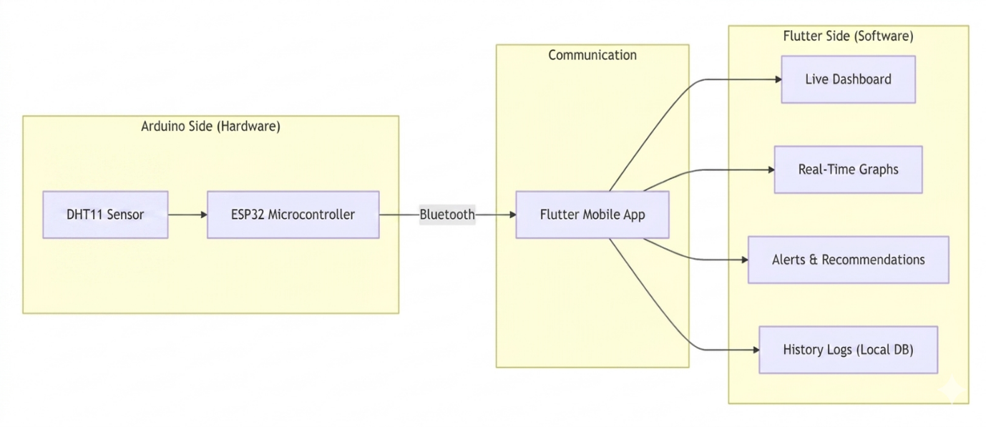
- Block Diagram (High-Level):

- Wiring Diagram (Pin Connections):
Component | ESP32 Pin
DHT11 Sensor
VCC (Pin 1) | 3.3V
DATA (Pin 2) | D2
GND (Pin 4) | GND
LCD MODULE
GND | GND
VCC | VIN
SDA | D21
SCL | D22
YELLOW LED
Cathode | GND
Anode | D27
GREEN LED
Cathode | GND
Anode | D26
RED LED
Cathode | GND
Anode | D25
PASSIVE BUZZER
Positive | D4
Negative | GND

*(Note: A pull-up resistor (4.7k - 10k Ohm) is typically required between DATA and VCC for the DHT11. Some modules have this built-in.)*

- Bill of Materials (BOM):
Quantity | Component
1 | ESP32 Development Board
1 | DHT11 Temperature and Humidity Sensor
1 | Breadboard (half-size)
10+ | Jumper Wires (Male-to-Female and Male-to-Male)
1 | Micro-USB Cable (for power and programming)
1 | Smartphone with Flutter app installed
3 | LED
1 | LCD 1602 Display Module
1 | Passive Buzzer
3 | 220 Ohms Resistor

4. Instructions: How It Works
- Setup Instructions:
  - Connect Hardware: Follow the wiring diagram above. Connect DHT11 to GPIO 4 and LDR analog output to GPIO 34 on the ESP32. Ensure all GNDs are common.
  - Install Arduino IDE: Install the Arduino IDE on your computer.
  - Add ESP32 Board: In Arduino IDE, go to File > Preferences, add https://raw.githubusercontent.com/espressif/arduino-esp32/gh-pages/package_esp32_index.json to "Additional Board Manager URLs". Then go to Tools > Board > Boards Manager, search for "ESP32", and install.
  - Install Libraries: Install the "DHT sensor library" by Adafruit via Library Manager.
  - Upload Code: Copy the provided Arduino sketch (which reads sensors and sends data via Wi-Fi). Change the Wi-Fi SSID and password in the code. Select the correct COM port and ESP32 board, then upload.
  - Run Flutter App:
    - Have Flutter SDK and Android Studio / VS Code installed.
    - Open the Flutter project.
    - Run flutter pub get to install dependencies (including fl_chart, shared_preferences or sqflite).
    - Connect your phone via USB with debugging enabled, or use an emulator.
    - Run flutter run to install and launch the app.
- Working Logic:
  - The ESP32 reads the DHT11 sensor for temperature and humidity every 2 seconds.
  - It also reads the analog value from the LDR (light sensor) on GPIO 34.
  - The ESP32 formats these three values into a simple string, e.g., 25.5,60,340.
  - This string is sent via HTTP POST request to the Flutter app's local IP address (the phone running the app acts as a temporary server).
  - The Flutter app:
    - Listens for incoming data on a specific port.
    - Splits the string "25.5,60,340" into separate numbers.
    - Updates the dashboard cards (e.g., Temperature, Humidity, Light).
    - Appends the new data point to a list, which updates the fl_chart real-time graph.
    - Checks thresholds: If temperature > 35°C, triggers an in-app alert popup and shows a recommendation: "Warning: High Temperature. Suggested: Turn on fan or AC."
    - Saves the reading (with timestamp) into a local SQLite database.
  - The user can switch to the "History" page to view past readings with time stamps.
- Testing & Troubleshooting Tips:

Common Issue | How to Solve
ESP32 not connecting to Wi-Fi | Double-check SSID and password. Ensure you are on a 2.4GHz network (ESP32 may not work with 5GHz).
Flutter app not receiving data | Ensure both phone and ESP32 are on the same Wi-Fi network. Check the IP address in the Arduino code matches the phone's IP. Disable phone firewall/VPN.
Temperature readings are 0 or NaN | Check DHT11 wiring. Ensure the data pin is connected to GPIO 4. Add a 4.7k - 10k pull-up resistor between DATA and 3.3V.
Graph not updating smoothly | Reduce the data send rate in Arduino (e.g., send every 5 seconds instead of 1 second). Ensure Flutter uses setState() efficiently or use StreamBuilder.
Light sensor reading is constant | Check LDR analog output is connected to an ADC-capable pin (GPIO 34 is fine). Vary light manually and watch serial monitor.

